1. **https://bzb.ro/stire/dupa-codlea-si-vulcanul-reuseste-sa-faca-rost-de-bani-pentru-a-repara-biserica-fortificata-a157931**

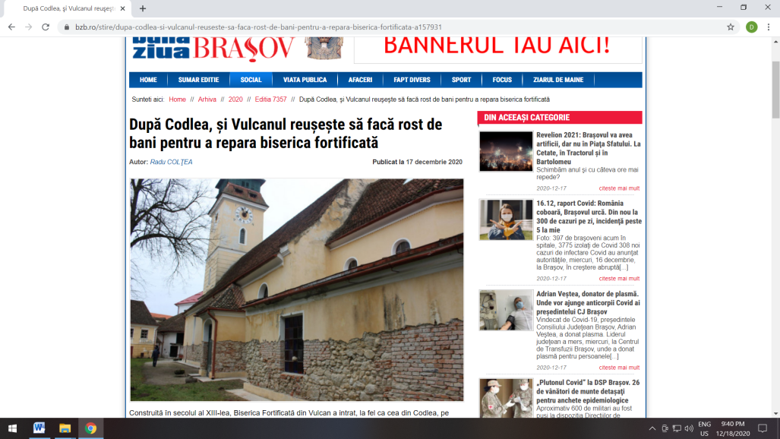

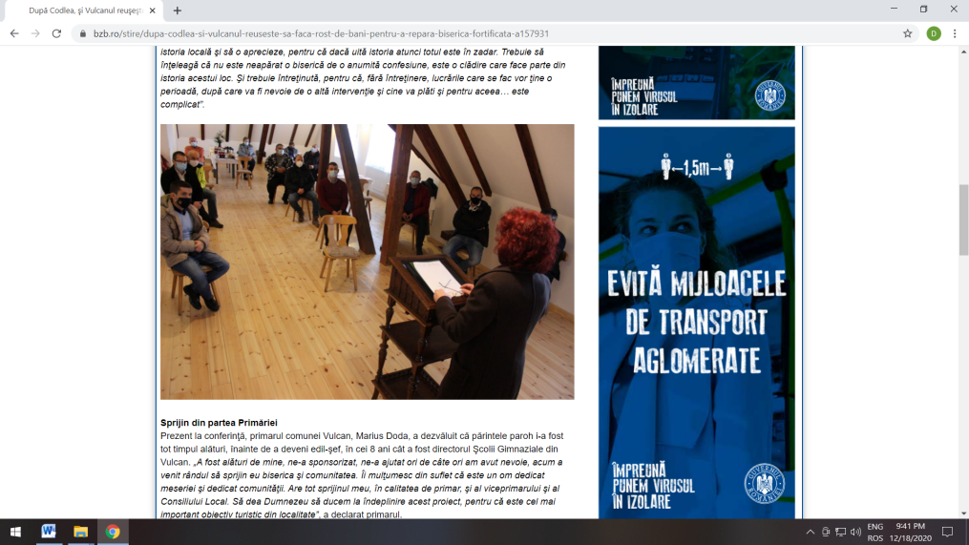

1. **https://www.bizbrasov.ro/2020/12/16/biserica-fortificata-din-vulcan-va-fi-restaurata-cu-15-milioane-de-lei-in-vederea-cresterii-atractivitatii-turistice/**

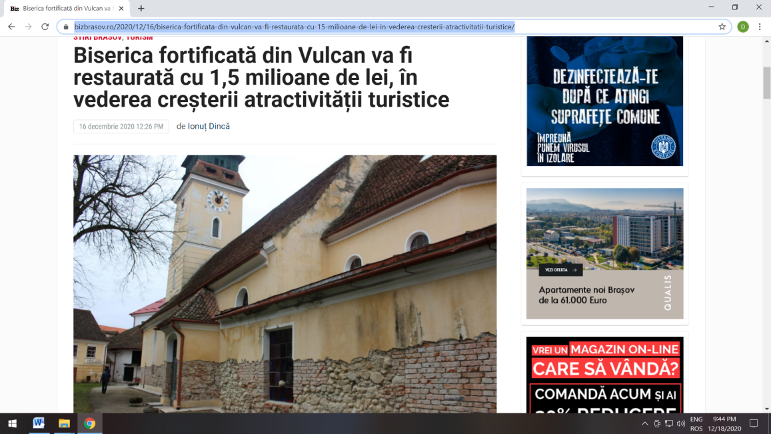

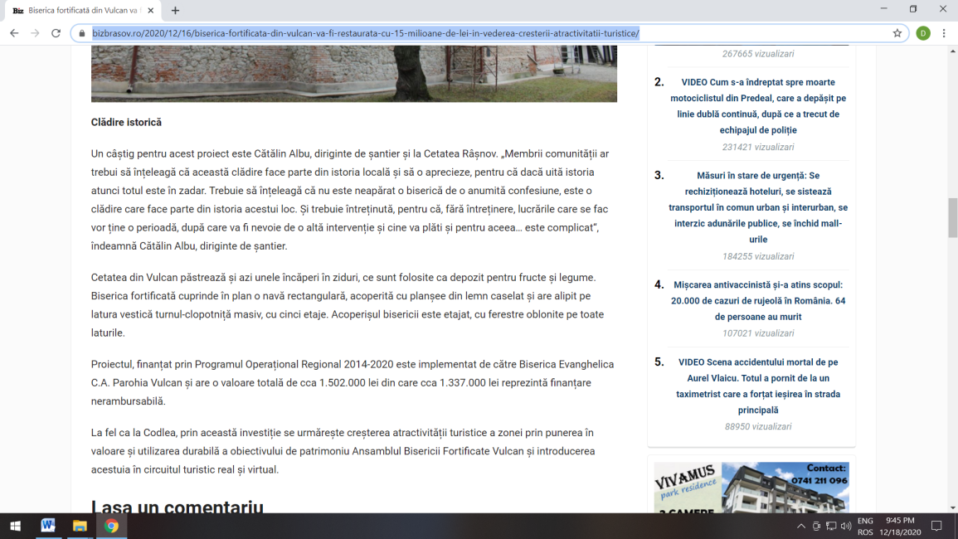

1. **https://brasovstiri.ro/au-inceput-lucrarile-de-reabilitare-la-biserica-fortificata-din-vulcan/**

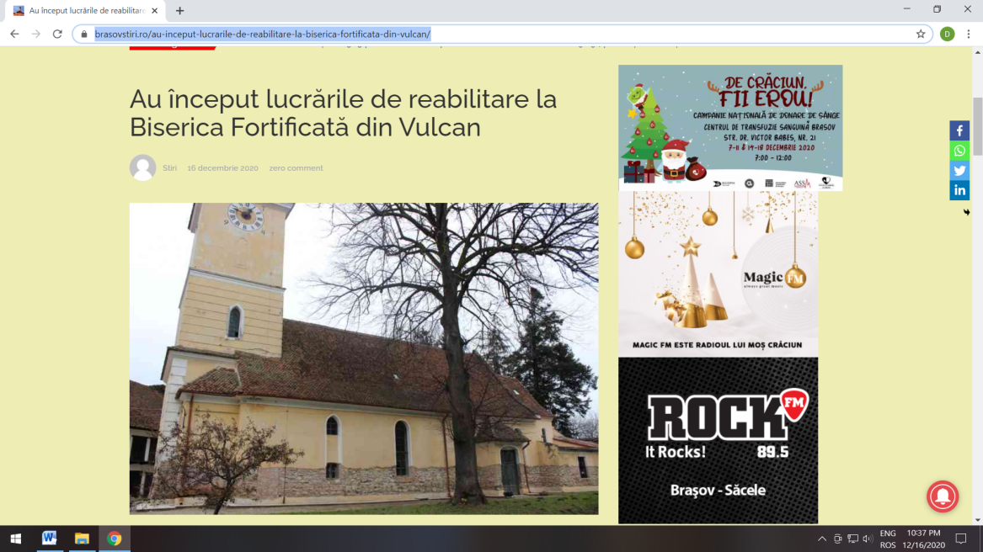

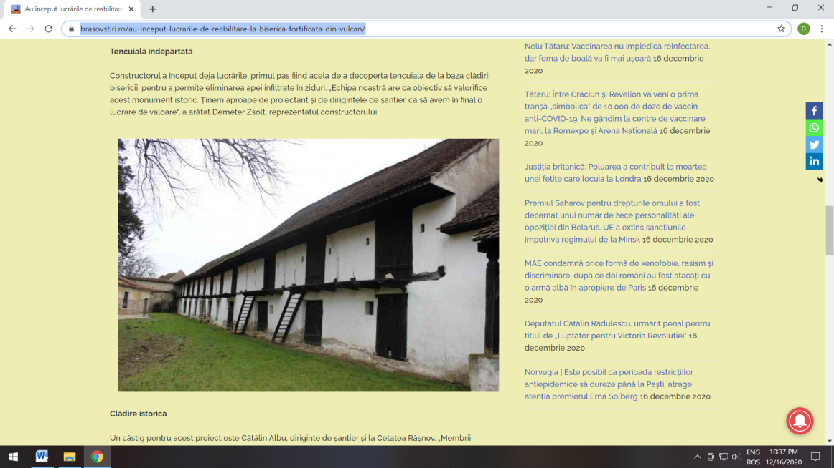

1. **http://www.coronapress.ro/articol/63031**

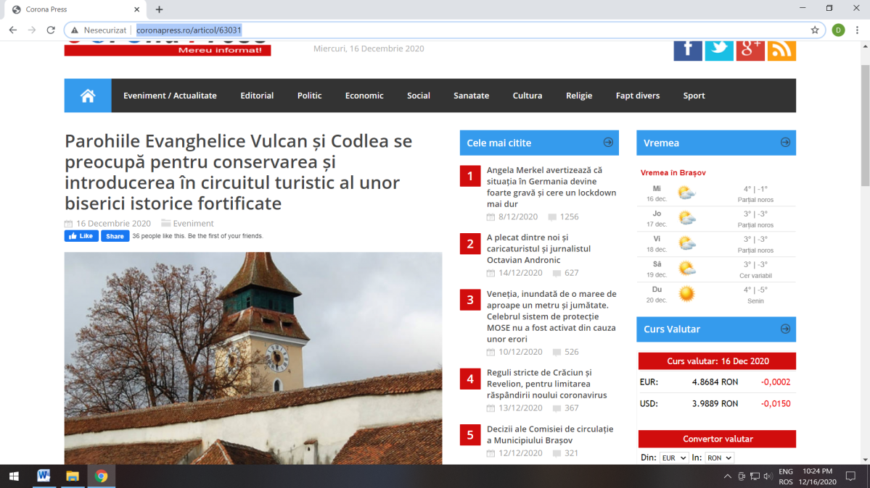

1. **https://www.monitoruldemedias.ro/2020/12/biserica-fortificata-din-vulcan-si.html**

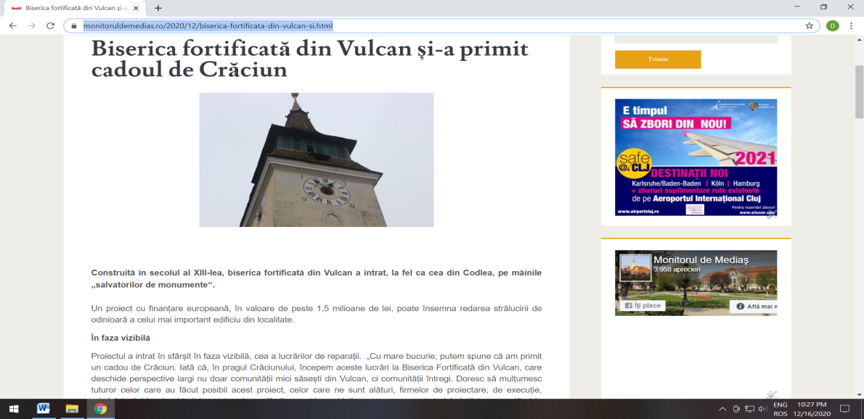

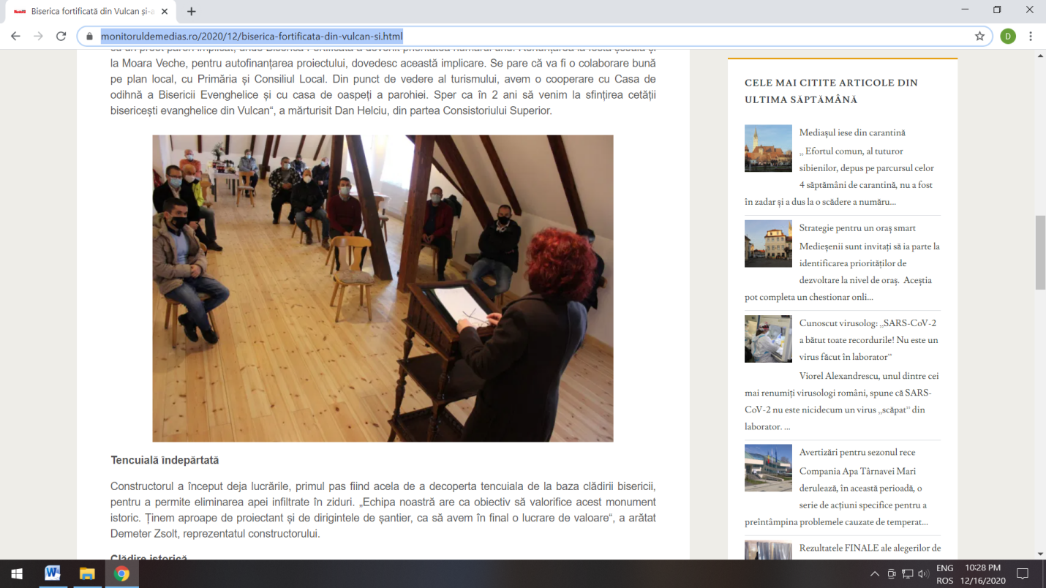

1. **https://www.mesageruldesibiu.ro/biserica-fortificata-din-vulcan-si-a-primit-cadoul-de-craciun/**

