1. **https://alba24.ro/video-descoperiri-arheologice-importante-inregistrate-dupa-restaurarea-bisericii-evanghelice-din-calnic-monument-istoric-unesco-1011974.html?fbclid=IwAR0InS4dOMwRFVz8PdyUcjk2Rkety1uH_Hlr5HfoWnVrDPqmlgwPxHIgYYA**

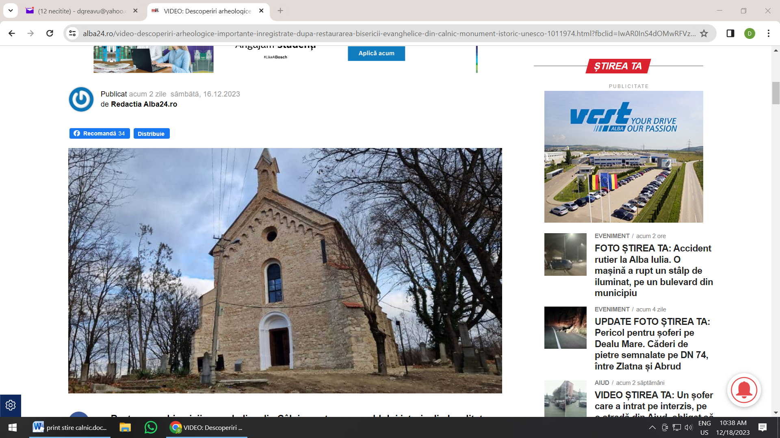

1. **https://mesageruldealba.ro/2023/12/18/biserica-evanghelica-din-calnic-comoara-din-patrimoniul-unesco/**

