1. **https://bzb.ro/stire/biserica-evanghelica-din-selistat-reabilitata-cu-bani-europeni-a193176**

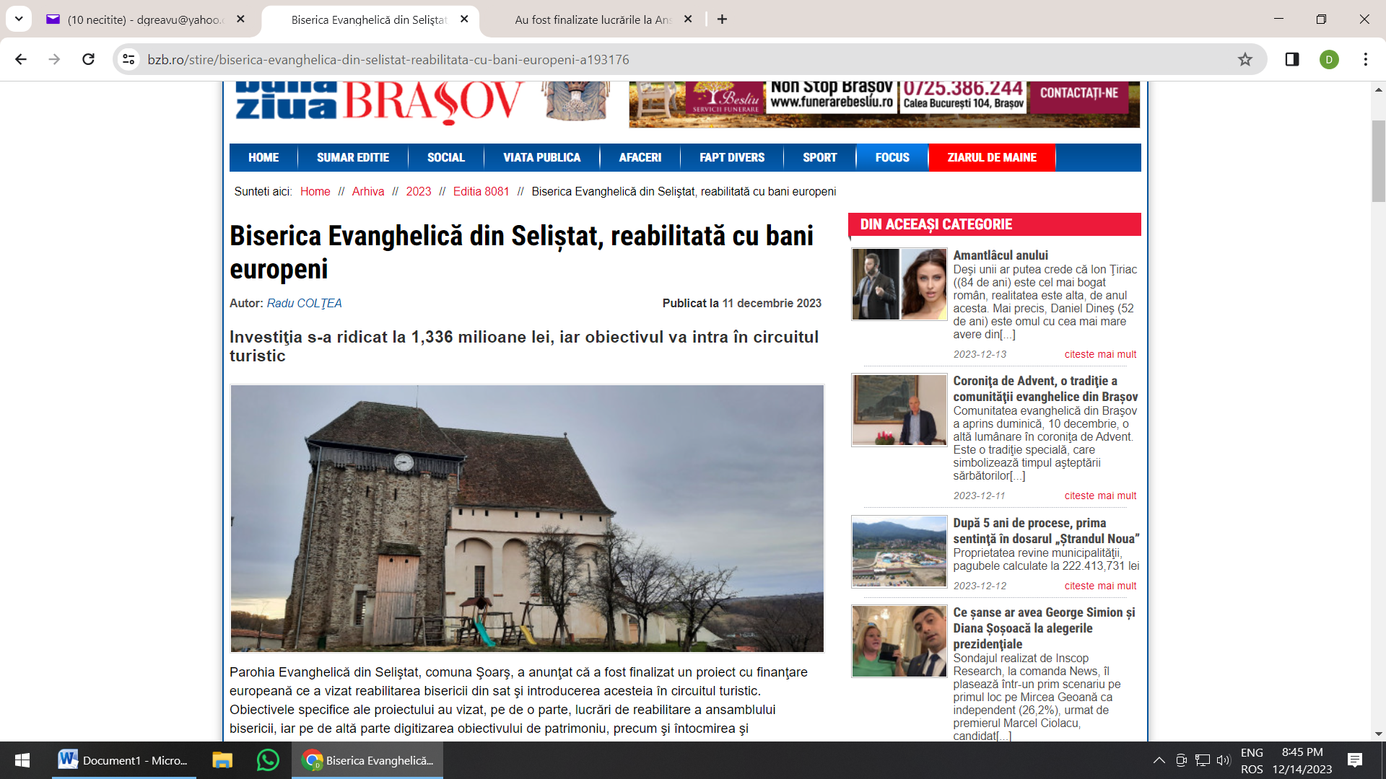

1. **https://www.monitorfg.ro/2023/12/14/bijuteria-de-la-selistat-biserica-fortificata-isi-redeschide-portile-pentru-turisti/**

